

Software Engineering Department
Braude College of Engineering
Final Project - Phase B (61999)

Real Impact Factor Evaluation Using Deep Learning
26-1-R-10

By:
Roni Brin 318295516
Shaked Turgeman 206180440

Supervisors:
Dr. Renata Avros
Prof. Zeev Volkovich

Link to GitHub

Table of contents
1 General Description 3
2 Solution Description 5
2.1 Research Pipeline 5
2.1.1 Data Collection 5
2.1.3 Baseline IF Computation 6
2.1.4 Deep Learning Model Training 7
2.1.5 Citation Stability Analysis 8
2.1.6 Real Impact Factor (RIF) Computation 8
2.2 Visualization and Result Evaluation 9
2.2.1 Model Learning Validation 9
2.2.2 Citation Stability Across Journals 10
2.2.3 Journal Ranking Changes 10
2.2.4 IF Overestimation Analysis 11
2.2.5 Threshold Sensitivity Analysis 12
2.2.6 Multi-Model Comparison 13
2.3 Research and Development Process 14
2.4 Tools Used 15
2.5 Challenges and Solutions 15
2.6 Results and Conclusions 16
2.7 Lessons Learned 16
2.8 Project Benchmarks 17
2.8.1 Research Benchmarks 17
2.8.2 Implementation Validation 17

Abstract
The Journal Impact Factor (IF) has long been one of the primary metrics for evaluating a scientific journal’s influence. The main limitation is that it assumes every citation carries the exact same weight, completely ignoring the reality that some citations are inherently more meaningful, reliable, and influential than others. Because of this, relying solely on citation counts can lead to an overestimation of a journal’s perceived scientific contribution. To address this issue, we developed the Real Impact Factor (RIF), a new framework that evaluates journals based on both the volume and, more importantly, the stability of their citations. Using the OpenAlex dataset, we built citation graphs that represent scientific papers as nodes and citations as directed edges. We then trained several graph-based models, including GraphSAGE, Variational Graph Autoencoder (VGAE), and Node2Vec, to analyze the relationships between these papers. To measure citation stability, we repeatedly perturbed the graphs by randomly removing citation edges and tracking how consistently each citation retained its importance across multiple graph versions. We then used these stability scores to calculate a weighted journal metric and compared it directly with the traditional Impact Factor. Our experiments show that the traditional IF routinely overestimates journal influence by treating all citations equally. By contrast, RIF offers a much more balanced assessment, giving greater weight to stable citations while reducing the impact of unstable ones. Additional tests, including journal ranking comparisons, threshold sensitivity experiments, and multi-year evaluations spanning 2010 to 2022, consistently demonstrated the framework’s reliability. Ultimately, this study shows that combining graph-based deep learning with citation stability analysis provides a more reliable and robust approach for measuring scientific impact than traditional citation-based metrics.
Keywords: Real Impact Factor (RIF), Impact Factor, Citation Networks, Graph Neural Networks, GraphSAGE, VGAE, Node2Vec, Citation Stability Analysis, OpenAlex

1 General Description
- Project Goal:
The Journal Impact Factor (IF) is one of the most widely used metrics for evaluating the scientific influence of journals. However, the traditional IF assumes that all citations contribute equally to a journal's impact, regardless of their quality, reliability, or long-term importance. This approach may lead to an overestimation of a journal's true scientific contribution. The goal of this research was to develop a new evaluation framework called Real Impact Factor (RIF), which incorporates citation stability into the journal evaluation process. Instead of counting all citations equally, our approach assigns different weights to citations according to their stability within a citation network. To achieve this goal, we combined citation network analysis with graph-based deep learning techniques. We investigated whether stable citations can provide a more accurate representation of scientific influence and whether RIF can serve as a more reliable alternative to the traditional Impact Factor.
Our research focused on three main objectives:
- Measuring citation stability using graph perturbation techniques.
- Developing a weighted journal metric based on citation stability.
- Comparing the traditional Impact Factor with the proposed Real Impact Factor across multiple years and scientific journals.
- Project Implementation:
The project was divided into several stages, starting from data collection and ending with the evaluation of the proposed framework.

- Data Collection - Scientific publication data was collected from the OpenAlex dataset for the years 2010-2022.
- Citation Graph Construction - Citation networks were created by representing papers as nodes and citations as directed edges.

- Baseline IF Computation - Traditional Impact Factor values were calculated to establish a baseline for comparison.

- Deep Learning Model Training - Three graph-based models (GraphSAGE, VGAE, and Node2Vec) were trained to learn the structure of the citation networks.

- Stability Analysis - Graph perturbation was performed by randomly removing citation edges multiple times and measuring citation consistency.

- RIF Computation - Stability scores were used to calculate the Real Impact Factor.

- Visualization and Result Evaluation - Different visualizations were created to compare IF and RIF and to analyze journal behavior over time.
- Research Outputs:
The research produced six main components:

Product 1 - Citation Graph Framework: A collection of citation networks built from the OpenAlex dataset, covering the years 2010-2022. Each graph represents scientific papers as nodes and citation relationships as directed edges.

Product 2 - Graph-Based Deep Learning Models: Three graph learning approaches were implemented and evaluated - GraphSAGE, Variational Graph Autoencoder (VGAE), and Node2Vec. These models were used to learn the structure of citation networks and support citation stability analysis.

Product 3 - Citation Stability Analysis Framework: A stability analysis mechanism based on graph perturbation was developed. Citation edges were repeatedly removed at random, and stability scores were calculated according to how consistently citations preserved their importance.

Product 4 - Real Impact Factor (RIF): A new weighted journal metric was developed by combining traditional citation counts with citation stability measurements.

Product 5 - Journal Evaluation Framework: A framework was created to compare journals using both IF and RIF, allowing changes in journal rankings and impact assessments to be analyzed.

Product 6 - Visualization and Evaluation Suite: A collection of visual analysis tools was developed to present the results. These visualizations include stability score distributions, IF versus RIF comparisons, journal ranking changes, threshold sensitivity analyses, and multi-year evaluations.
- Stakeholders:
The results of this research may be useful for several groups:

- Academic Researchers
- Universities and Research Institutions
- Scientific Publishers
- Researchers in Scientific Impact Analysis
- Funding Agencies

These stakeholders can use the proposed framework to obtain a more balanced and reliable evaluation of scientific journals.
Overall, the proposed framework provides a new perspective on journal evaluation by incorporating citation stability into traditional citation-based metrics and offering a more balanced assessment of scientific impact.
The following chapters provide a detailed description of the research methodology, experiments, obtained results, and their evaluation.

2 Solution Description

2.1 Research Pipeline

2.1.1 Data Collection
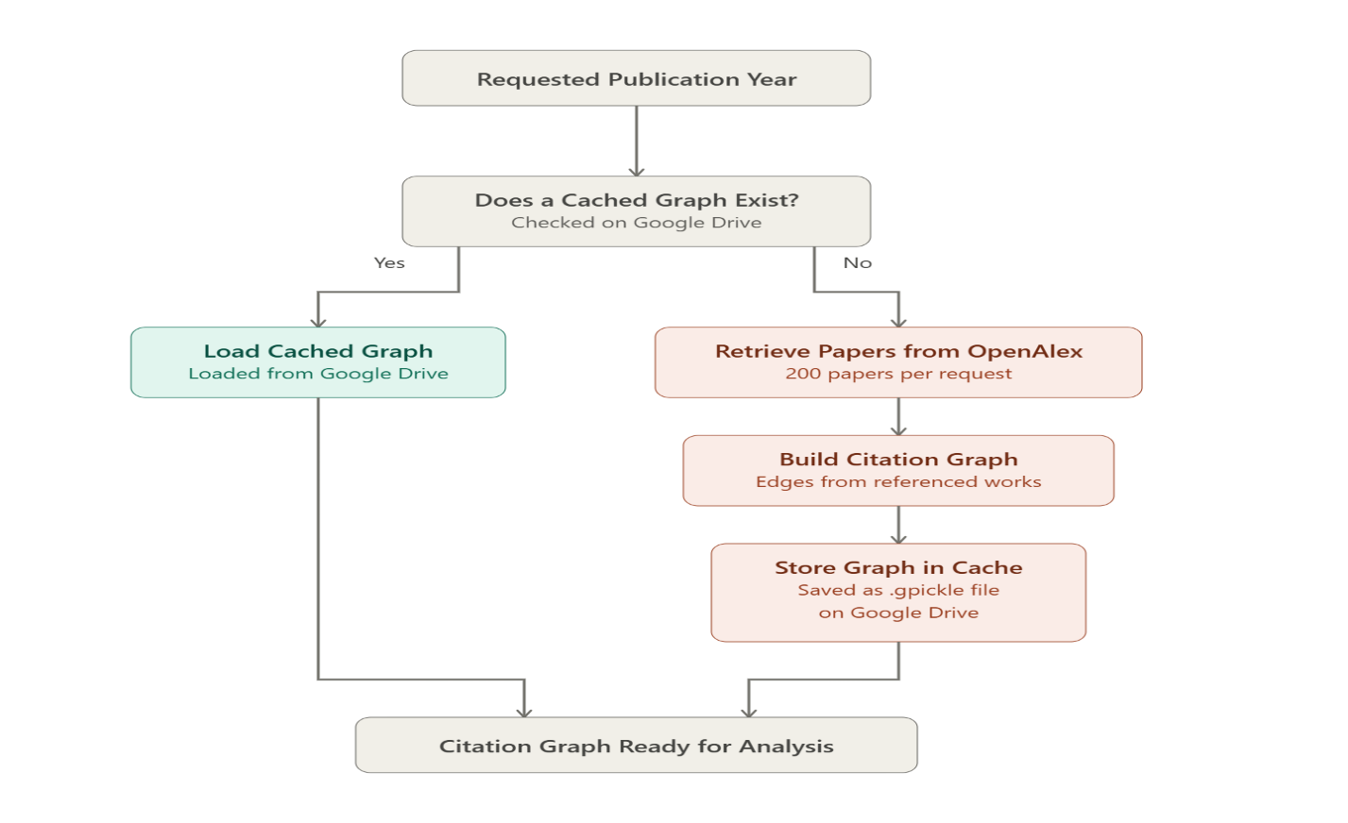
The first stage of the research focused on collecting scientific publication data from the OpenAlex dataset. OpenAlex is an open-access database that provides large-scale information about scientific publications, journals, authors, institutions, and citation relationships. For this study, data from the years 2010 to 2022 was collected in order to analyze citation behavior over an extended period of time. For each year, up to 50,000 scientific papers were retrieved and prepared for further analysis. The collected information included paper identifiers, publication years, journal names, and citation relationships between papers. The collected data was then used to construct yearly citation networks, which served as the foundation for all subsequent stages of the research. Since graph construction is computationally expensive, each generated graph was stored as a cache file (.gpickle) on Google Drive. This allowed future experiments to load existing graphs directly instead of rebuilding them for every execution. This caching mechanism significantly reduced execution time and enabled efficient multi-year experiments and comparative analyses.
Figure 1. The workflow of the data collection and graph caching process used to prepare citation networks for analysis.
2.1.2 Citation Graph Construction
During this stage, we transformed the collected publication data into yearly citation networks. Each scientific paper was represented as a node, while citation relationships between papers were represented as directed edges connecting the citing paper to the cited paper. For every publication year, a separate directed graph was constructed using the NetworkX library. Each node contained several attributes, including the publication year and the journal name, which were later used for journal-level analysis and metric computation. The citation graphs served as the core data structure throughout the entire research process. They were used for baseline Impact Factor calculations, deep learning model training, citation stability analysis, and the computation of the proposed Real Impact Factor (RIF). Since the graphs were generated independently for each year, the framework enabled temporal comparisons and allowed us to analyze how citation patterns changed over time. In order to ensure data consistency, several validation tests were performed. These tests verified that every node contained the required attributes, all citation edges connected existing papers, and the resulting networks were stored as directed graphs.
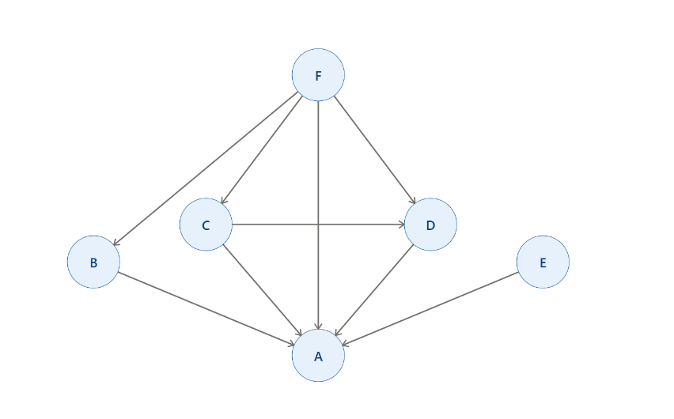

Figure 2. An example of a citation network in which papers are represented as nodes and citation relationships are represented as directed edges.

2.1.3 Baseline IF Computation
At this stage, we calculated the traditional Journal Impact Factor (IF) in order to establish a baseline for comparison with the proposed Real Impact Factor (RIF). The traditional IF evaluates a journal's influence by treating all citations equally, without considering their reliability, long-term importance, or structural role within the citation network. For each target year, the calculation was performed with respect to the beginning of that year and considered papers published during the two preceding years. For every journal, we counted all citations associated with papers published during this two-year period and divided this value by the total number of papers published by the same journal during that period. This process produced a baseline Impact Factor value for each journal and each analyzed year. The calculated IF values served as a reference throughout the research and were later compared with the weighted RIF values. This comparison allowed us to investigate whether incorporating citation stability could provide a more balanced and accurate representation of scientific impact. To ensure the correctness of the implementation, validation tests were performed before applying the calculation to the entire dataset. After validation, baseline IF values were computed for all journals for each analyzed year and were subsequently used for journal ranking analyses and multi-year evaluations. The table below presents an example of baseline Impact Factor values calculated for five selected journals in 2018. The values summarize the number of papers published during 2016-2017, the number of citations associated with those papers, and the resulting Impact Factor used as a reference metric throughout the research.
Journal | Papers | Citations | IF
ACS Nano | 500 | 1036 | 2.072
FEBS Letters | 211 | 22 | 0.1043
Nature Genetics | 432 | 424 | 0.9815
Nature Medicine | 365 | 286 | 0.7836
Brain Research | 500 | 39 | 0.078
Table 1. Traditional Impact Factor (IF) values for selected journals, including the number of published papers and received citations.

2.1.4 Deep Learning Model Training
At this stage, we trained graph-based deep learning models to learn the structural relationships between scientific papers and to support the citation stability analysis performed later in the research. Since scientific publications naturally form a network, graph learning approaches were chosen instead of traditional machine learning techniques. Three different models were implemented and evaluated: GraphSAGE, Variational Graph Autoencoder (VGAE), and Node2Vec. Each model analyzes the citation network differently and provides an additional perspective on the relationships between papers. GraphSAGE was used as the main model throughout the research. The model consisted of three GraphSAGE convolutional layers with a hidden dimension of 128 and an output dimension of 64. The input features included publication year information and journal identifiers extracted from the citation graphs. For each analyzed year, the model was trained for 100 epochs using the Adam optimizer. During training, the learning rate was gradually reduced in order to improve convergence and stabilize the optimization process. The training loss consistently decreased over time, indicating that the model successfully learned meaningful structural patterns from the citation networks. The trained embeddings were later used as the basis for the citation stability analysis. The same training procedure was repeated independently for each analyzed year, allowing us to perform multi-year comparisons while preserving temporal consistency between experiments. The training process served as a critical step in the proposed framework, since the quality of the learned graph representations directly influenced the accuracy of the subsequent stability measurements and the computation of the Real Impact Factor (RIF).
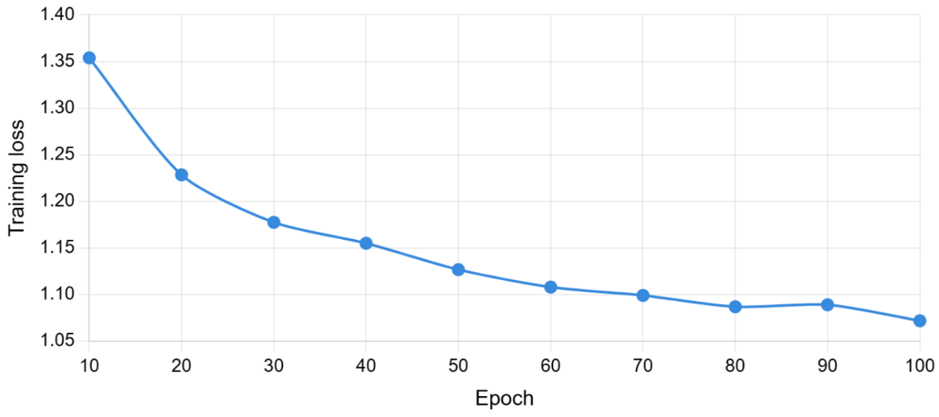

Figure 3. The GraphSAGE training loss for the 2018 citation network across 100 training epochs.

2.1.5 Citation Stability Analysis
At this stage, we measured citation stability by evaluating how consistently citation relationships were preserved under repeated graph perturbations. The main assumption behind this approach is that not all citations contribute equally to scientific influence. Some citations remain important even when the citation network is slightly modified, while others are more sensitive to structural changes. To quantify citation stability, we repeatedly generated modified versions of each yearly citation graph by randomly removing a portion of the citation edges. This perturbation process was repeated 100 times for every analyzed year. After each perturbation, the trained GraphSAGE model produced updated representations for the papers, allowing us to evaluate whether a citation preserved its structural importance. For every citation edge, a stability score between 0 and 1 was calculated according to the percentage of perturbation experiments in which the citation remained significant. Higher stability scores indicate citations that consistently preserve their role within the network, while lower scores indicate citations that are more sensitive to changes. The stability scores later served as the foundation for the Real Impact Factor (RIF) computation. Instead of treating all citations equally, stable citations received a larger contribution to the final journal score, while unstable citations received a smaller contribution. The histogram below presents the distribution of stability scores for the 2018 citation network. The obtained distribution showed a bimodal behavior, with a high concentration of citations near stability scores of 0 and 1. This indicates that the model was able to clearly distinguish between unstable citations and highly stable citations instead of assigning similar values to all citation relationships. These findings suggest that the model successfully captured meaningful structural patterns within the citation network and support the assumption that citations should not all be treated equally.
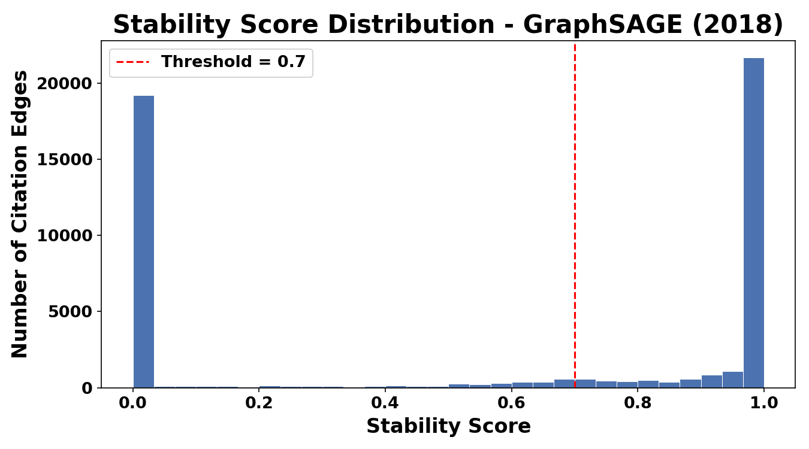

Figure 4. The distribution of citation stability scores for the 2018 citation network.

2.1.6 Real Impact Factor (RIF) Computation
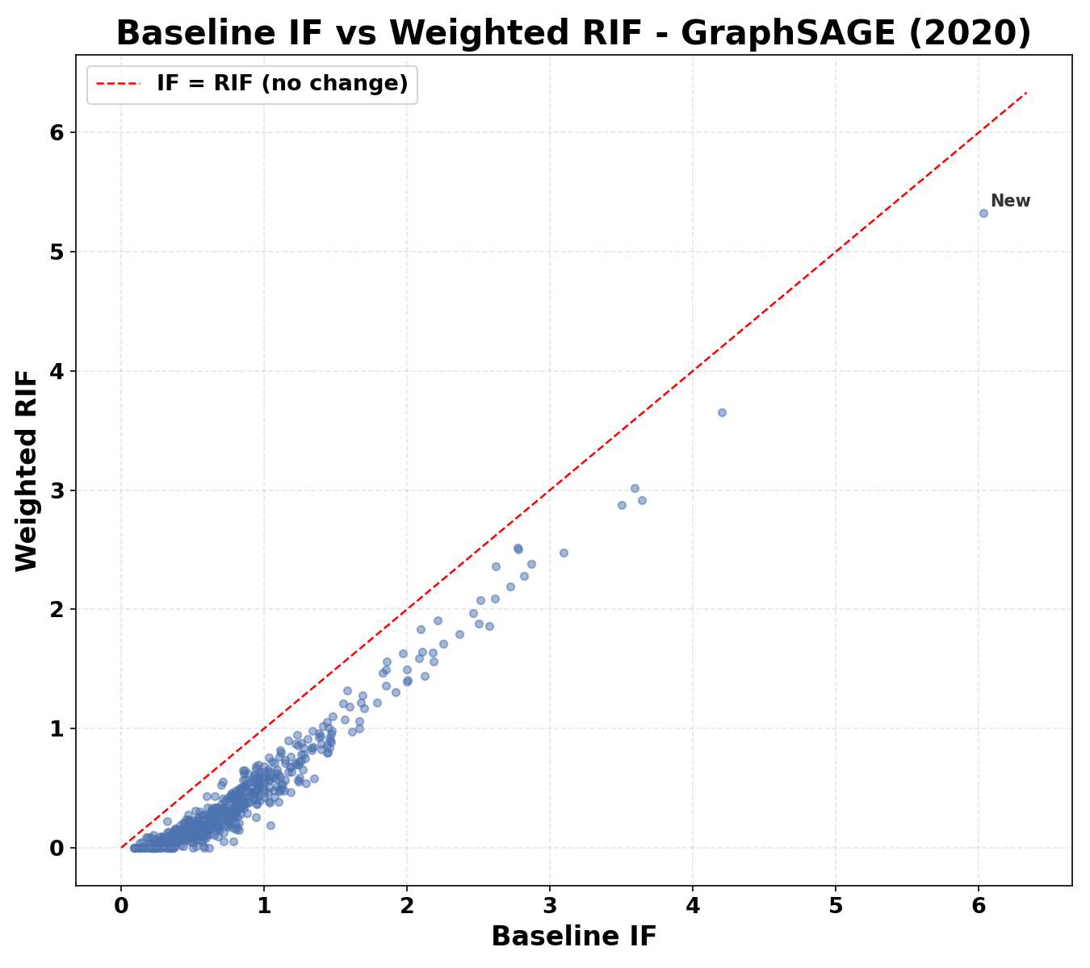
At this stage, we computed the Real Impact Factor (RIF), which is the main metric proposed in this research. Unlike the traditional Impact Factor, which treats every citation equally, RIF incorporates citation stability into the journal evaluation process. For every analyzed year, the stability scores calculated in the previous stage were assigned as weights to the citation relationships. Citations that consistently preserved their importance across perturbation experiments received higher weights, while unstable citations received lower weights. These weighted citations were then aggregated at the journal level to produce a new journal impact metric. The RIF calculation was performed independently for every journal and every analyzed year. This approach enabled direct comparisons between the traditional Impact Factor and the proposed Real Impact Factor while preserving temporal consistency throughout the experiments. To evaluate the effect of citation weighting, we compared the baseline IF values with the corresponding RIF values. The results showed that RIF consistently produced lower values than the traditional Impact Factor. This behavior indicates that the traditional IF may overestimate journal influence by treating all citations equally, whereas RIF provides a more balanced assessment by emphasizing stable citation relationships. The scatter plot below presents the relationship between IF and RIF values for all journals in 2020. Each point represents a single journal. The diagonal line represents the theoretical case in which IF and RIF are identical. Most journals appear below this line, indicating that RIF generally produces lower values than IF. In addition, the varying distances from the diagonal line show that the reduction is not uniform across journals. These findings suggest that citation stability is not distributed equally and that different journals are affected differently by the weighting process.

Figure 5. A comparison between traditional Impact Factor (IF) and Real Impact Factor (RIF) values for journals in 2020.

2.2 Visualization and Result Evaluation
This section presents the visual evaluation of the proposed framework. The generated visualizations were used to validate the model's behavior, analyze citation stability, compare IF and RIF values, evaluate the robustness of the methodology, and verify the consistency of the obtained results. The evaluation was divided into five groups, each addressing a different research objective. Together, these analyses provide evidence that incorporating citation stability produces a more informative and balanced journal evaluation metric than traditional citation counting alone.

2.2.1 Model Learning Validation
The first evaluation stage focused on verifying whether the GraphSAGE model successfully learned meaningful structural patterns from the citation network. To perform this evaluation, we analyzed the distribution of citation stability scores obtained after the perturbation experiments. The stability scores revealed a clear bimodal distribution, with a large concentration of citations near values of 0 and 1, while relatively few citations received intermediate values. This behavior indicates that the model did not assign similar scores to all citation relationships. Instead, the model successfully differentiated between unstable citations and highly stable citations. This finding suggests that the model learned meaningful structural properties of the citation network and supports the assumption that citations have different levels of importance. As shown in Figure 4, the stability score distribution provides the first indication that the proposed framework can distinguish between different types of citation relationships rather than treating all citations equally.

2.2.2 Citation Stability Across Journals
At this stage, we analyzed how citation stability differs across journals and over time. Instead of examining individual citation relationships, we aggregated the results at the journal level and measured how much the Real Impact Factor (RIF) differs from the traditional Impact Factor (IF) for each journal. The heatmap presents the percentage reduction from IF to RIF for selected journals between 2018 and 2022. Larger reductions indicate that a journal contains a higher proportion of unstable citations, while smaller reductions indicate more stable citation patterns. The results show that citation stability is not distributed uniformly across journals. Some journals, such as The Lancet, consistently exhibit moderate reductions over multiple years, whereas others show substantial changes only during specific periods. In addition, certain journals display very high reductions during individual years, suggesting that their scientific influence relies heavily on unstable citation relationships. These findings demonstrate that journals are affected differently by citation stability and support the main assumption of this research: not all citations should contribute equally when evaluating scientific impact.
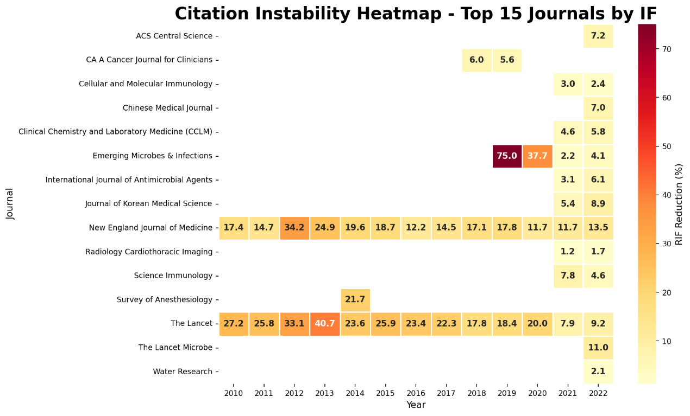

Figure 6. The percentage reduction from traditional Impact Factor (IF) to Real Impact Factor (RIF) for selected journals between 2018 and 2022.

2.2.3 Journal Ranking Changes
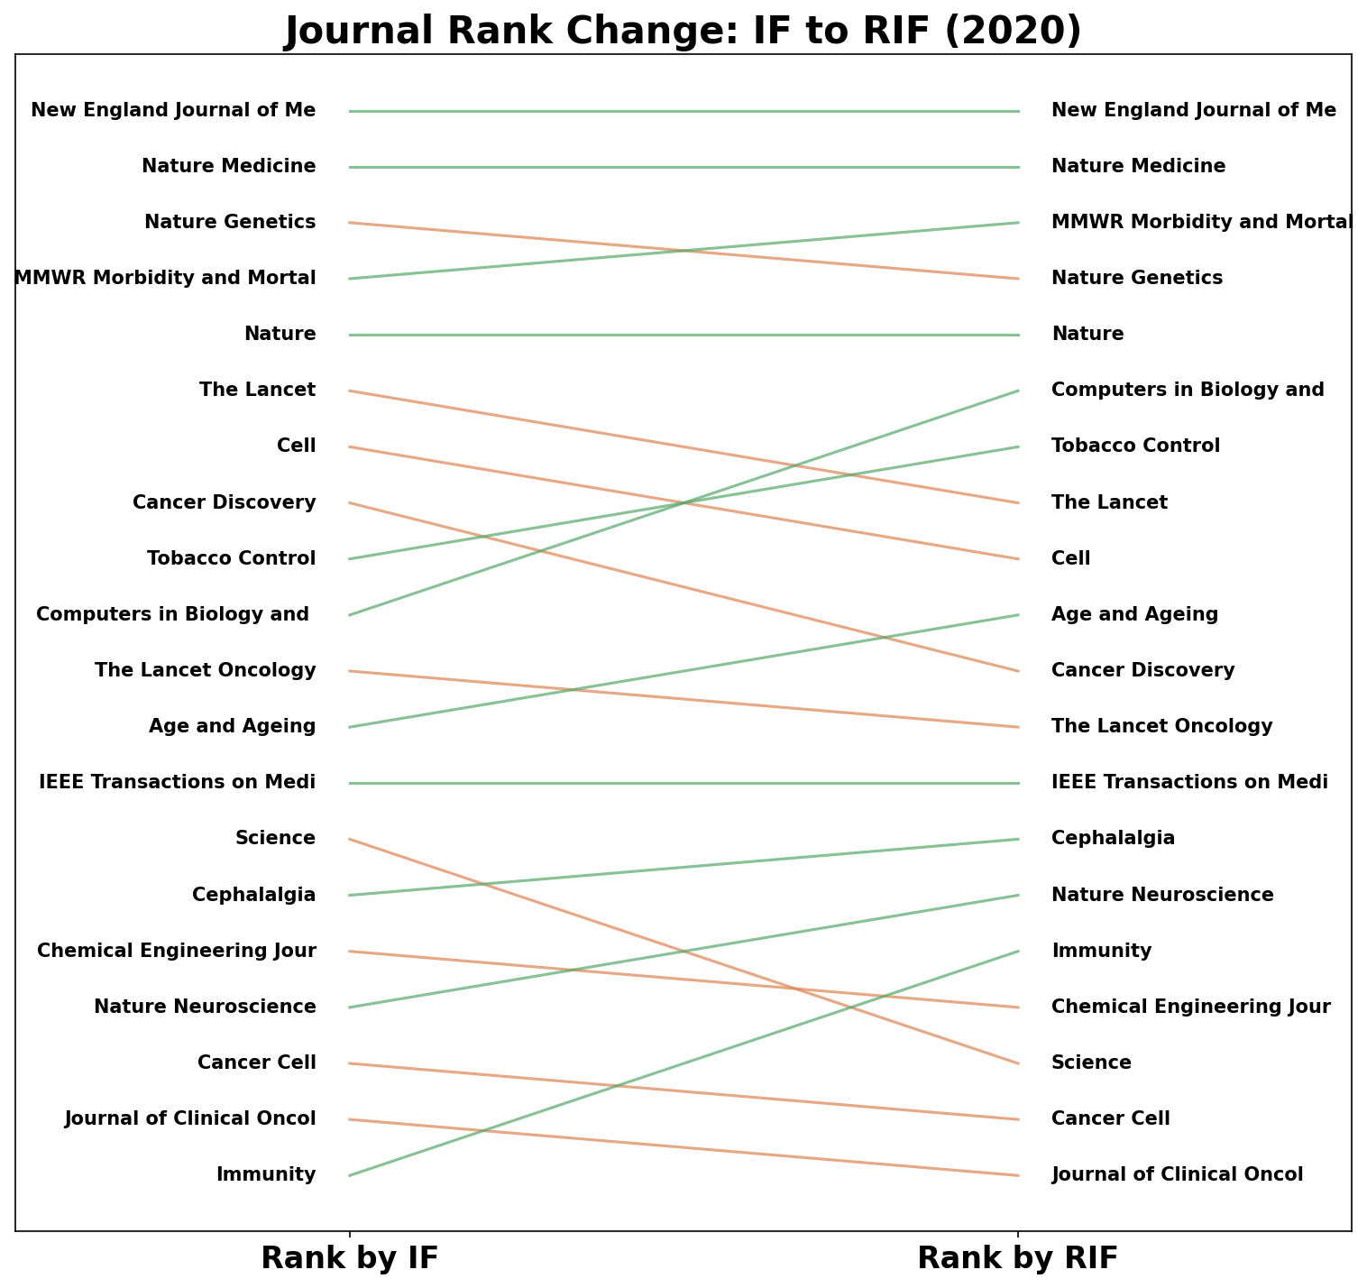
At this stage, we analyzed how journal rankings change after replacing the traditional Impact Factor (IF) with the proposed Real Impact Factor (RIF). Rather than focusing on the absolute values of the metrics, this analysis examined the relative position of each journal. The figure compares the ranking of journals before and after incorporating citation stability into the evaluation process. Several journals maintained their positions, while others experienced noticeable changes. Some journals moved up in the ranking, indicating that their scientific influence is supported by highly stable citation relationships. In contrast, journals that moved down appear to rely more heavily on unstable citations. These findings demonstrate that citation stability can substantially affect journal evaluation and that journal rankings are not fixed when citation quality is considered. Overall, the results show that RIF provides additional information beyond simple citation counts and can reveal differences that are hidden in traditional IF rankings.

Figure 7. A comparison between journal rankings based on traditional Impact Factor (IF) and Real Impact Factor (RIF) in 2020.

2.2.4 IF Overestimation Analysis
At this stage, we measured how much the traditional Impact Factor (IF) overestimates journal influence compared to the proposed Real Impact Factor (RIF). For every journal, we calculated the difference between IF and RIF values and analyzed the distribution of these differences across all journals. Positive values indicate that IF assigns a higher score than RIF, while values close to zero indicate similar evaluations. The results show that most journals exhibit positive differences, suggesting that the traditional IF systematically overestimates scientific impact by treating all citations equally. In addition, the distribution is not uniform, indicating that some journals are affected more strongly than others. These findings further support the assumption that citation quality should be considered when evaluating scientific influence and demonstrate the advantage of incorporating citation stability into journal assessment.
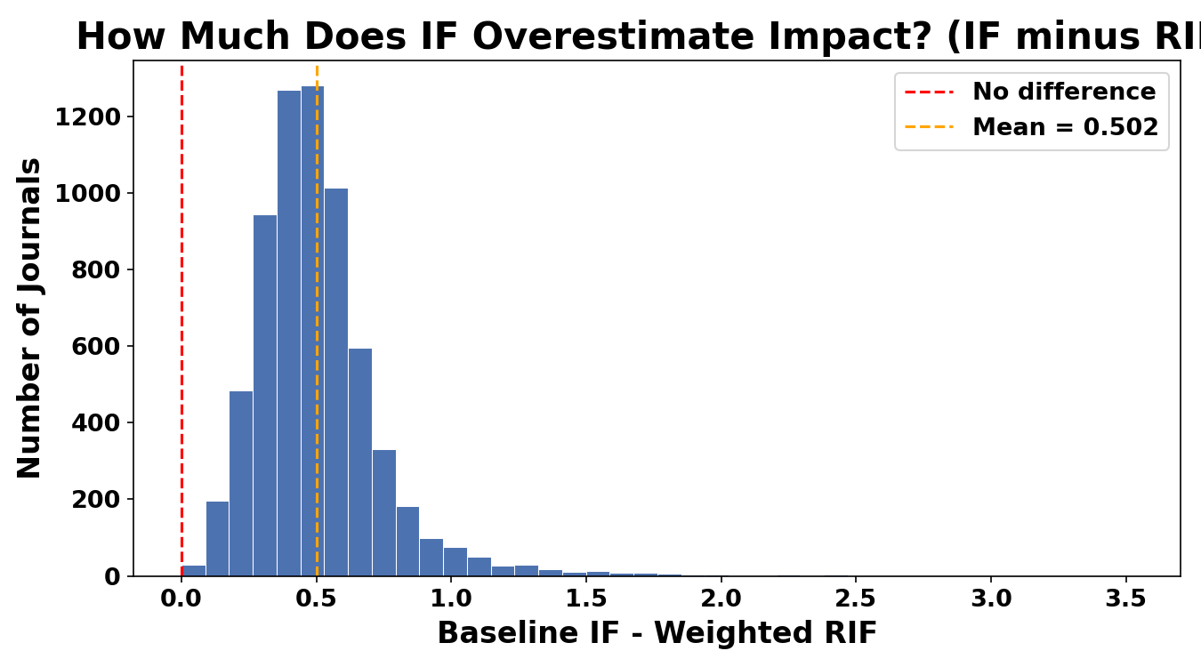

Figure 8. The distribution of the differences between traditional Impact Factor (IF) and Real Impact Factor (RIF) across all journals.

2.2.5 Threshold Sensitivity Analysis
At this stage, we evaluated the robustness of the proposed methodology by examining the effect of different stability thresholds on the resulting RIF values. Since citation stability is used to weight citations, changing the threshold could potentially affect the final journal scores. To test this, we recalculated the average weighted RIF values using threshold values ranging from 0.5 to 0.9 for all analyzed years. The results show that although higher thresholds produce lower RIF values, the overall trends remain consistent across years. In particular, all threshold curves follow a similar pattern and exhibit the same increase in recent years. These findings indicate that the proposed framework is not highly sensitive to the exact threshold selection and that the results remain stable under different parameter settings. Therefore, the methodology demonstrates robustness and does not rely on a single threshold value to produce meaningful results. Overall, these findings strengthen the reliability of the proposed Real Impact Factor framework and support its use as a more informative alternative to the traditional Impact Factor.
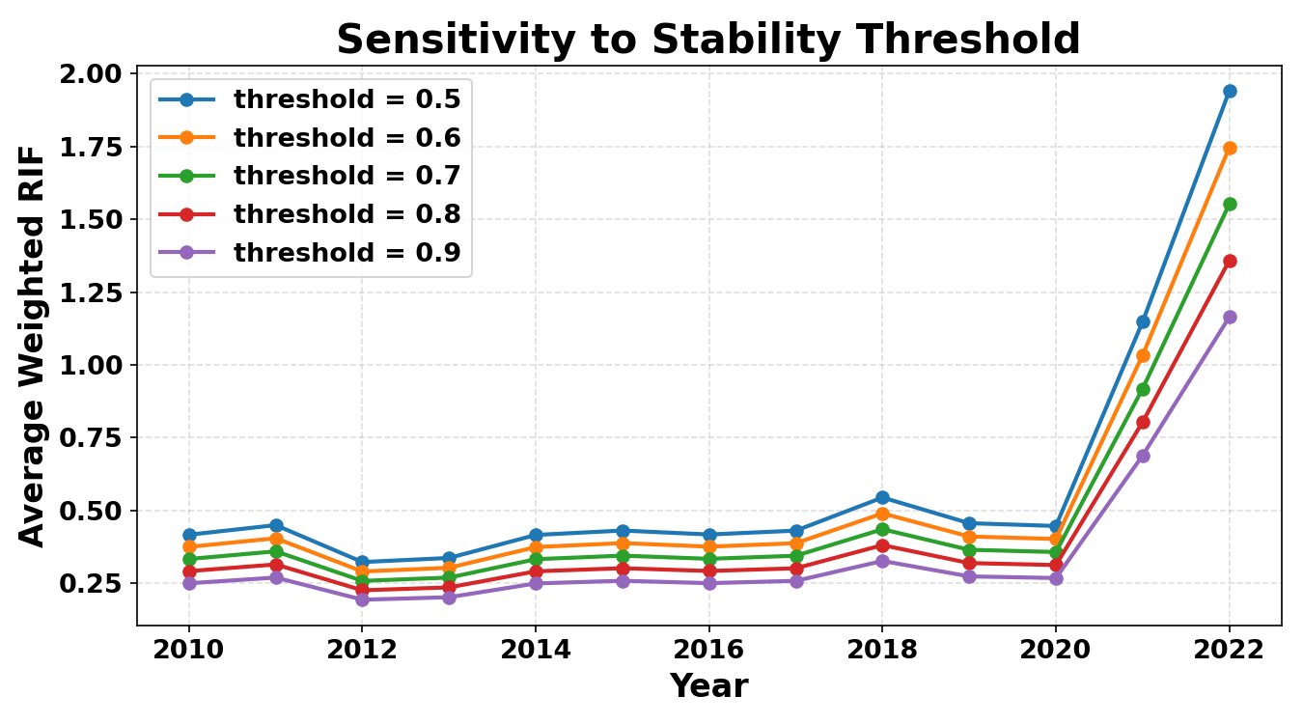

Figure 9. The average weighted RIF values computed using different stability thresholds between 2010 and 2022.

2.2.6 Multi-Model Comparison
To further evaluate the proposed framework, we compared the results produced by the three graph-based models: GraphSAGE, VGAE, and Node2Vec. This comparison was performed to verify that the obtained findings are not specific to a single model architecture. First, we compared the average weighted RIF values produced by each model between 2018 and 2022. Although the absolute values differed, all models exhibited similar temporal trends and showed a noticeable increase in recent years. Next, we measured the agreement between the models by comparing their journal-level RIF values. The obtained correlations were very high, indicating strong consistency between different model architectures. We also analyzed the percentage reduction from traditional IF to RIF. The results showed that each model reduced journal scores differently, but all models consistently produced lower values than the traditional Impact Factor. Finally, we directly compared IF and RIF for all three models in 2020. Most journals remained below the diagonal reference line, further supporting the conclusion that traditional IF systematically overestimates scientific influence. Overall, these results demonstrate that the proposed framework is robust and that its main conclusions remain valid across different graph-learning approaches.
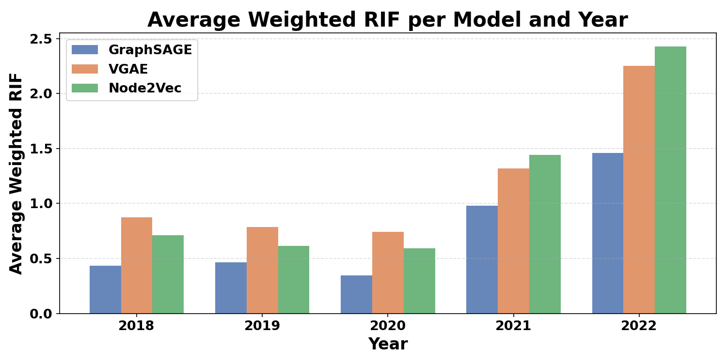

Figure 10. Average weighted RIF values produced by GraphSAGE, VGAE, and Node2Vec between 2018 and 2022
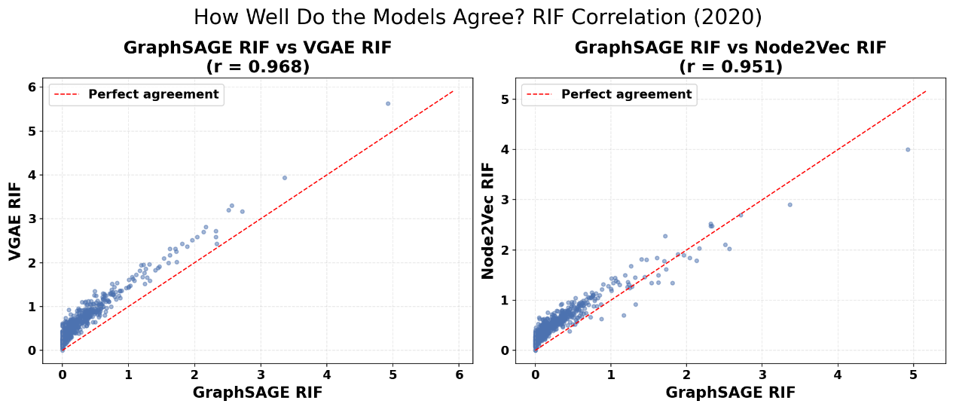

Figure 11. Correlation between RIF values generated by different models in 2020
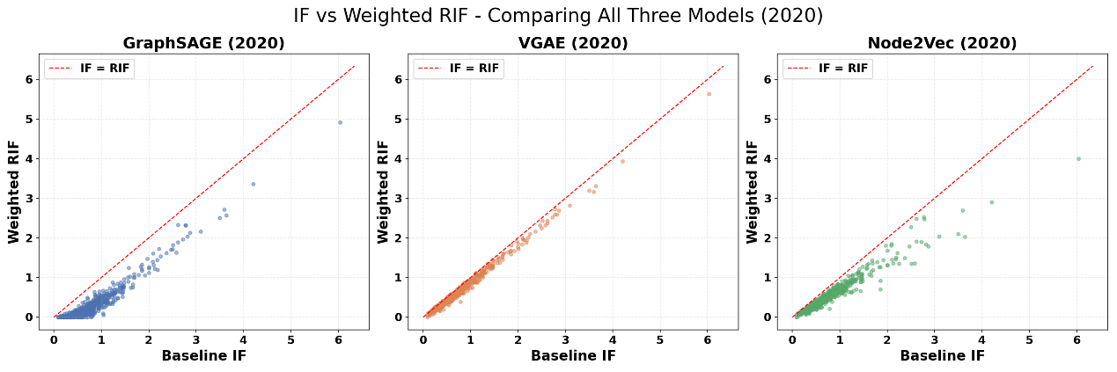
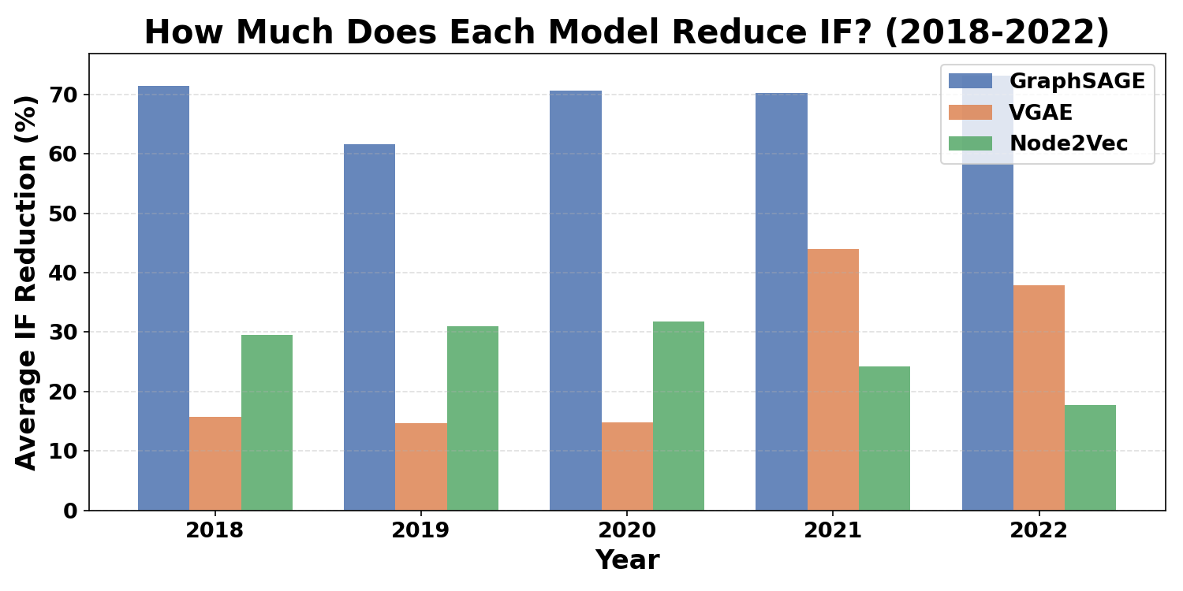
Figure 12. Average IF reduction percentages obtained by each model between 2018 and 2022

Figure 13. Comparison between traditional IF and weighted RIF for all three models in 2020

2.3 Research and Development Process
This section describes the research and development process used to build the proposed framework. The project was developed incrementally, starting from raw scientific publication data and ending with a complete evaluation framework for scientific journal assessment. The first stage focused on collecting scientific publication data from the OpenAlex dataset for the years 2010 to 2022. Citation networks were then constructed by representing papers as nodes and citation relationships as directed edges. Additional information, such as publication year and journal name, was stored as node attributes to support later computations. Next, traditional Impact Factor (IF) values were calculated to establish a baseline for comparison. This allowed the proposed methodology to be evaluated against a widely accepted journal evaluation metric. After constructing the citation networks, three graph-based deep learning models were trained and evaluated. GraphSAGE was applied to the entire time period between 2010 and 2022, while Variational Graph Autoencoder (VGAE) and Node2Vec were evaluated for the years 2018 to 2022. These models were used to learn structural patterns within citation networks and generate meaningful representations of citation relationships. To evaluate citation stability, graph perturbation experiments were performed by repeatedly removing a portion of citation edges and measuring how consistently each citation preserved its importance. The resulting stability scores were then incorporated into the Real Impact Factor (RIF) computation. Finally, multiple visualizations were created to analyze the obtained results. These visualizations were used to validate the model behavior, compare IF and RIF values, analyze journal ranking changes, and verify the robustness of the proposed methodology. Throughout the development process, several challenges were encountered, including long execution times, large graph sizes, and computational complexity. To address these issues, intermediate results such as citation graphs and trained models were stored and reused, significantly reducing the overall execution time of the experiments. Overall, the project was developed as a complete research pipeline that combines graph neural networks, citation stability analysis, and journal evaluation into a unified framework.

2.4 Tools Used
Several software libraries, frameworks, and online resources were used throughout the research in order to build, train, and evaluate the proposed framework. These tools supported different stages of the project, including data collection, graph construction, deep learning model training, data analysis, and visualization generation. Python was used as the main programming language due to its extensive ecosystem for data science and machine learning applications. OpenAlex served as the primary data source and provided scientific publication data and citation relationships. NetworkX was used to construct and manipulate citation graphs, while PyTorch and PyTorch Geometric were used to implement and train the graph-based deep learning models. In addition, Pandas and NumPy were used for data preprocessing and numerical computations. Matplotlib was used to generate the visualizations presented throughout the research. Google Colab was used as the development environment and enabled efficient execution of computationally intensive experiments.
The following table summarizes the main tools used during the project.

Tool | Purpose
Python | Main programming language
OpenAlex | Scientific publication dataset
NetworkX | Citation graph construction
PyTorch | Deep learning implementation
PyTorch Geometric | Graph neural network implementation
Pandas | Data preprocessing
NumPy | Numerical computations
Matplotlib | Data visualization
Google Colab | Experiment execution environment

Table 2. Software tools and technologies used throughout the project and their respective purposes

2.5 Challenges and Solutions
During the development of the project, several technical and computational challenges were encountered. Since the research involved large-scale citation networks and multiple deep learning models, special attention was required to ensure efficient execution and reliable results. One of the main challenges was the large size of the citation graphs. Processing thousands of papers and citation relationships for multiple years required significant computational resources and increased execution times. To address this issue, generated citation graphs were stored as cache files and reused in future experiments instead of being reconstructed every time. Another challenge was the long training time required for the deep learning models. Since multiple experiments were performed for different years, intermediate results and trained models were saved and reused whenever possible. In addition, graph perturbation experiments required repeatedly modifying the citation networks and recalculating stability scores. This process increased the computational complexity of the project and required careful optimization to maintain reasonable execution times. Finally, an important research challenge was validating that the proposed methodology produced meaningful results and was not dependent on a single parameter configuration. To address this issue, several visual analyses and threshold sensitivity experiments were performed. The following table summarizes the main challenges and the corresponding solutions implemented during the project.
Challenge | Solution
Large citation graphs | Stored citation graphs as cache files
Long execution times | Reused intermediate results and trained models
Computational complexity of perturbations | Optimized experiments and processed data incrementally
Evaluating methodology reliability | Performed threshold sensitivity analysis
Traditional IF limitations | Developed the Real Impact Factor (RIF) framework

Table 3. Challenges encountered throughout the project and the corresponding solutions that were applied

2.6 Results and Conclusions
In this project, we introduced the Real Impact Factor (RIF), a new way to evaluate scientific journals by taking citation stability into account. Unlike the traditional Impact Factor (IF), which treats all citations the same, our approach gives different importance to citations based on how stable they are within citation networks. The results showed that citation stability adds useful information that cannot be obtained from citation counts alone. The GraphSAGE model was able to distinguish between stable and unstable citations, showing that meaningful patterns were learned from the citation networks. We also found that journals are affected differently when citation stability is included in the calculation. Some journals showed only small changes between IF and RIF, while others experienced much larger reductions. In addition, several journals changed their ranking after applying RIF, suggesting that traditional citation counts do not always provide a complete picture of scientific influence. The threshold sensitivity analysis also showed that the results remained consistent when different threshold values were used. This indicates that the proposed framework is stable and does not depend on a single parameter setting. Overall, the results support our main assumption that not all citations should contribute equally when evaluating scientific journals. By combining graph-based deep learning with citation stability analysis, we were able to create a more balanced and reliable evaluation framework. We believe that the Real Impact Factor can serve as a useful complementary metric to the traditional Impact Factor and may help improve future journal evaluation methods.

2.7 Lessons Learned
During this project, we learned that evaluating scientific influence is much more complex than simply counting citations. One of the main lessons was that different citations can have different levels of importance, and treating all of them equally may lead to inaccurate results. We also gained practical experience working with large-scale datasets and graph-based deep learning models. Building and analyzing citation networks helped us better understand how scientific papers are connected and how these connections can be used to extract meaningful information. Another important lesson was the value of experimentation. Throughout the project, we tested different models, parameter settings, and evaluation methods. This process helped us verify that the results were consistent and that the proposed framework was reliable. In addition, we improved our technical skills in Python, data processing, graph analysis, and visualization techniques. Working on a long-term research project also strengthened our ability to plan tasks, solve problems, and manage a complex development process. Overall, this project showed us how machine learning and network analysis can be combined to create a more informative way to evaluate scientific journals.

2.8 Project Benchmarks

2.8.1 Research Benchmarks
To evaluate the success of the project, we defined several benchmarks that reflect the main goals of the research. These benchmarks helped us verify that the proposed framework works as expected and provides meaningful results. The first benchmark was to verify that the model learned meaningful patterns from the citation networks. This was achieved by analyzing the stability score distribution and confirming that the model could distinguish between stable and unstable citations. The second benchmark was to show that journals are affected differently when citation stability is taken into account. The journal-level analyses demonstrated that some journals experienced larger reductions than others, indicating that citation quality varies across journals. Another benchmark was to compare the traditional Impact Factor (IF) with the proposed Real Impact Factor (RIF). The results showed that RIF consistently produced lower values and changed the ranking of several journals. Finally, we verified that the methodology remained stable under different threshold values. This demonstrated that the framework is robust, reliable, and does not depend on a single parameter setting.
Benchmark | Outcome
Model learning validation | The model successfully distinguished between stable and unstable citations
Journal-level analysis | Different journals were affected differently by citation stability
IF versus RIF comparison | RIF produced lower values than IF
Journal ranking analysis | Several journals changed their ranking
Threshold sensitivity analysis | The methodology remained stable

Table 4. Project benchmarks and the outcomes used to evaluate the effectiveness and reliability of the proposed framework

2.8.2 Implementation Validation
To verify that the implementation works as expected, we performed automated tests on the main components of the project using the pytest framework. The tests were divided into three groups: data, model, and utils. The data tests verified the integrity of the citation graphs, including node attributes, graph directionality, graph loading and saving operations, and the correctness of both IF and RIF computations. The model tests verified the GraphSAGE architecture, the training process, and the generated embeddings. The utility tests verified the perturbation mechanism, stability score calculations, and the RIF computation functions. All tests passed successfully without errors. In total, 32 out of 32 tests passed, indicating that the framework behaves as expected and that its main components are internally consistent and reliable.

Module | Description | Number of Tests | Result
Data | Citation graph construction, IF and RIF computations, graph validation | 13 | Passed
Model | GraphSAGE architecture and training process | 7 | Passed
Utils | Perturbation, stability score computation, and RIF functions | 12 | Passed
Total | Complete framework validation | 32 | Passed

Table 5. Summary of the automated tests performed on the main project modules

